Why DentalClinic-Website?

Since years when doctors decided to open clinic they advertise about it into journalism or poster but many people may couldn't saw it or it might damage so this wested money, effort and time.

Technology develop in recent years.

Many people use it so we think of making website to abounds our time, efforts, money and enable people to see our clinic services minutely and made him to make an appointment at any time

Dental Clinic



Welcome to our dental clinic

* Our dental clinic designed to make your smile brighter.
* Dental Clinic helps you achieve the quintessentially Oriented Smile you have always craved.
* Our product gets the job done without making you go through any hassle or discomfort.

**Home**

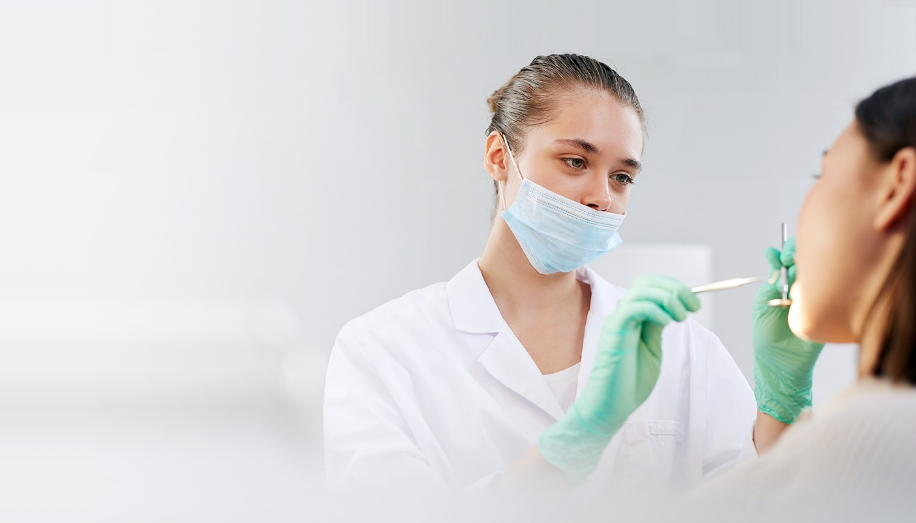

Dental Clinic Can Help You Get The Smile You've Always Wanted. We Offer Cosmetic Dentistry, Root Canal Therapy, Cavity Inspections, And more.

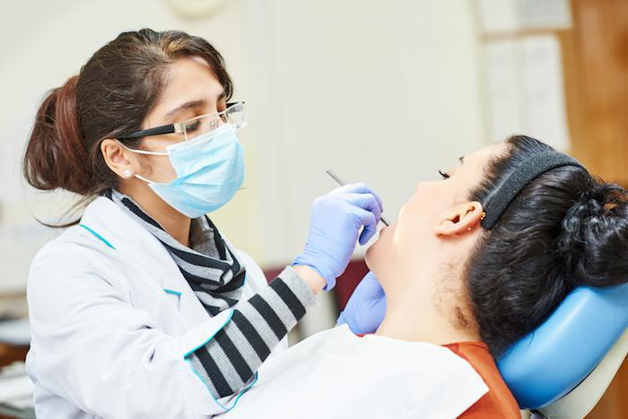

About Us

**Genuine Family Healthcare.**

**Dental Clinic Helps You Achieve The Q**

**uintessentially Oriented Smile You Have Always Craved. Our Product Gets The Job Done Without Making You Go Through Any Hassle Or Discomfort.**

# OUR SERVICES

* **Alignment Specialist**

He corrects the position of your teeth and jaws.

### Cosmetic Dentistry.

### It improves the appearance of a person

### teeth,gums and bits.

### Oral Hygiene Experts.

### It is treating and maintaining your overall

### oral health.

### Root Canal Specialist.

### He removes diseased or injured pulp tissue.

### Cavity Inspection.

### It starts with a whitish or chalk appearance on the enamel of your teeth.

# WORK PROCESS

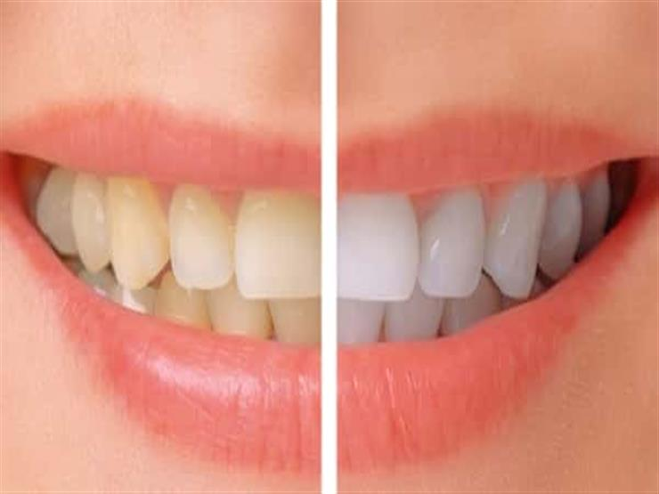

### Cosmetic Dentistry

### Includes Teeth Whitening, Dental Implants, Dental Crowns, And Teeth Shaping.

### 

### Pediatric Dentistry

Pediatric Dentistry Include Stainless Steel Crowns, Tooth-Colored Fillings, Dental Cleanings, An civities.

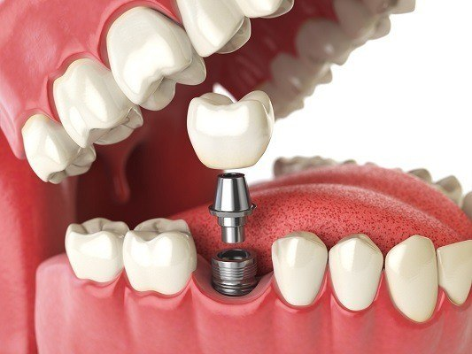

### Dental Implants

Dental Implants Are Artificial Tooth Roots That Are Surgically Placed Into The Jawbone .

# OUR CLIENTS

# 



# **Mohamed Alaa (manager)**

### I Couldn’t Believe That It Was So

### Afordable Compared To The

### Alternatives Available In The Market.

### 

 **Sanaa (Assistant Manager)**

Earlier I Used To Hide My Smile And Now I Can’t Stop Smiling. Flexalign

### Aligners Changed My Life & Smile Completely

.

Mohamed Ali(ECO)

### Great Experience With Dental Clinic

### Aligners. I Would Recommend This

### Place For They Have The Best

### Quality Service.

Patient personal details

**All the details of the patient are recorded from the options given here .**

**The patient information includes patient name, number,email ,appointment date .**

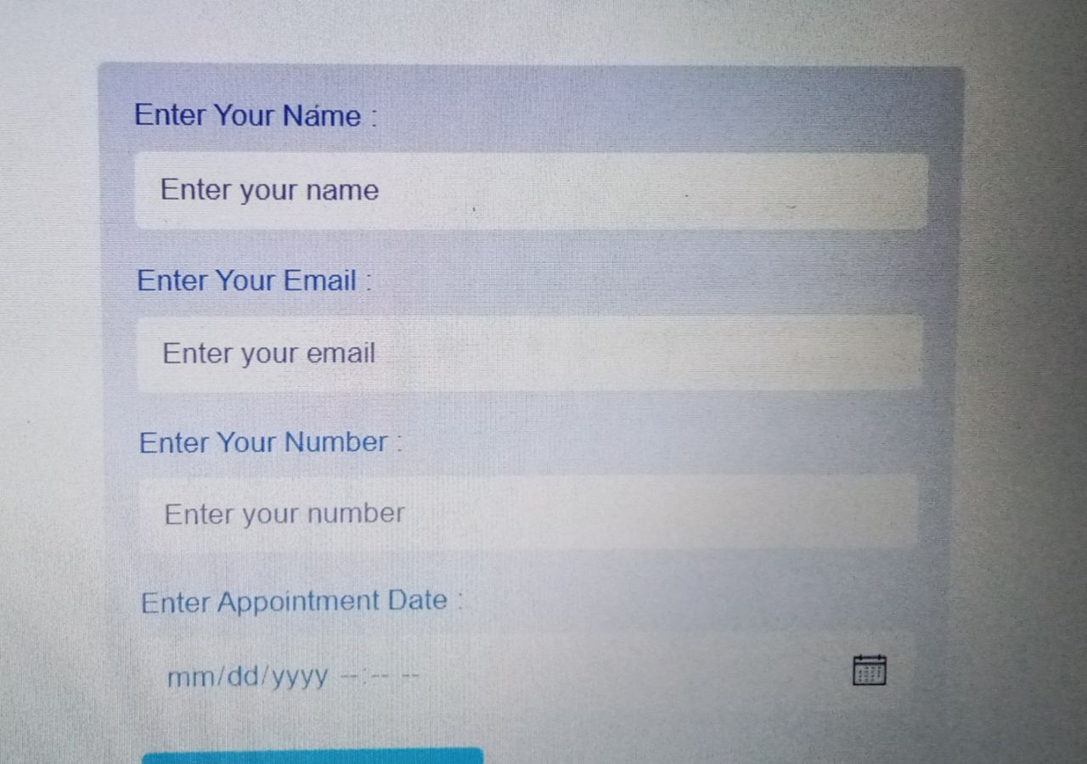

Tools

* Visual studio code
* XAMPP control panel

Languages

* HTML
* CSS
* PHP
* MY SQL

Html code

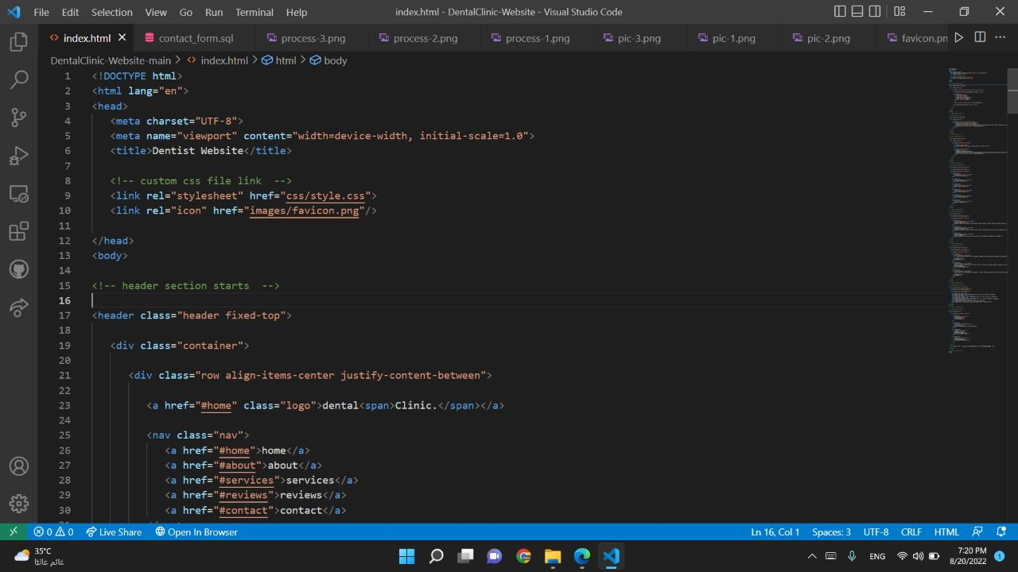

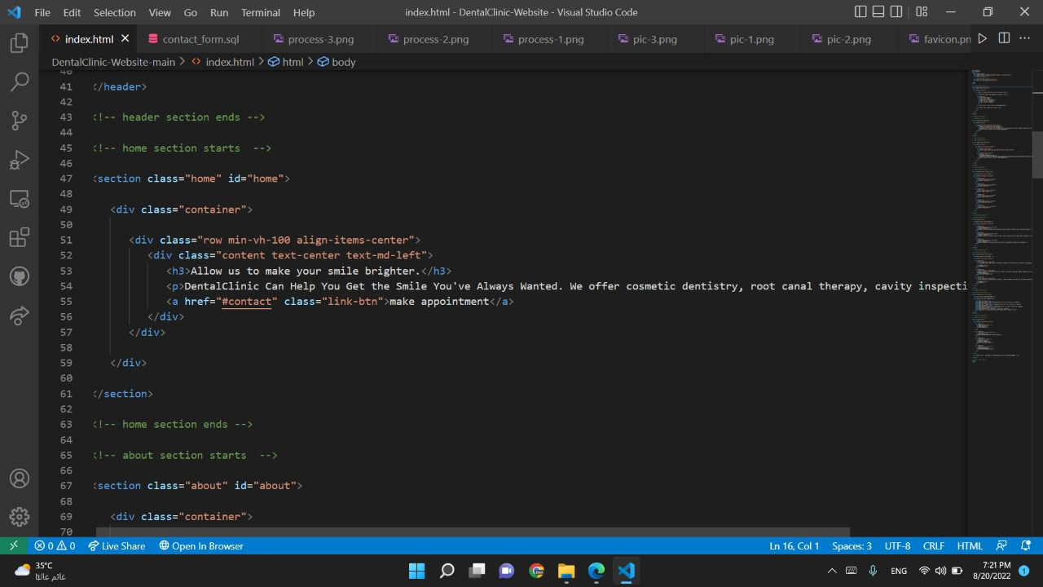

### 

### 

### 

### 

### 

**CSS Code**

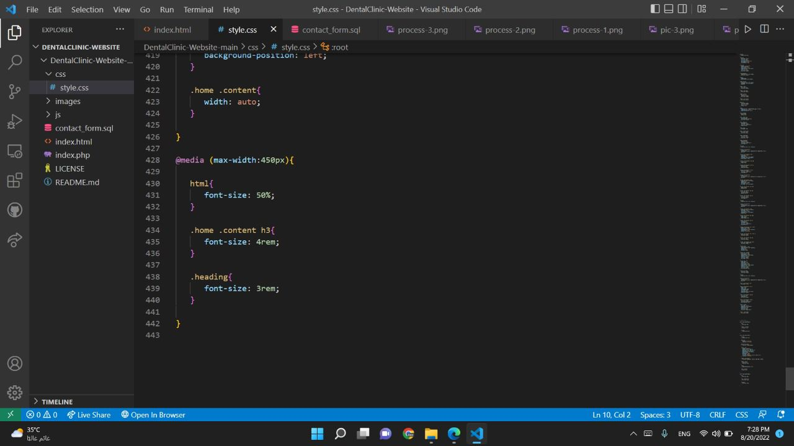

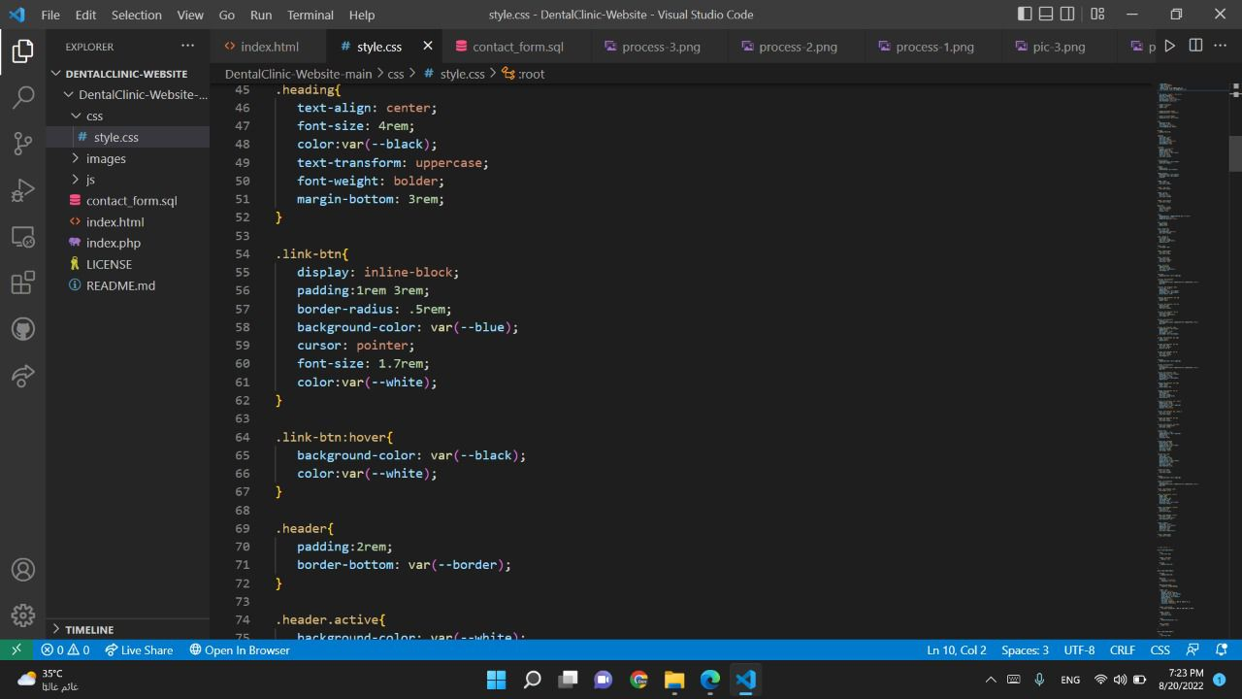

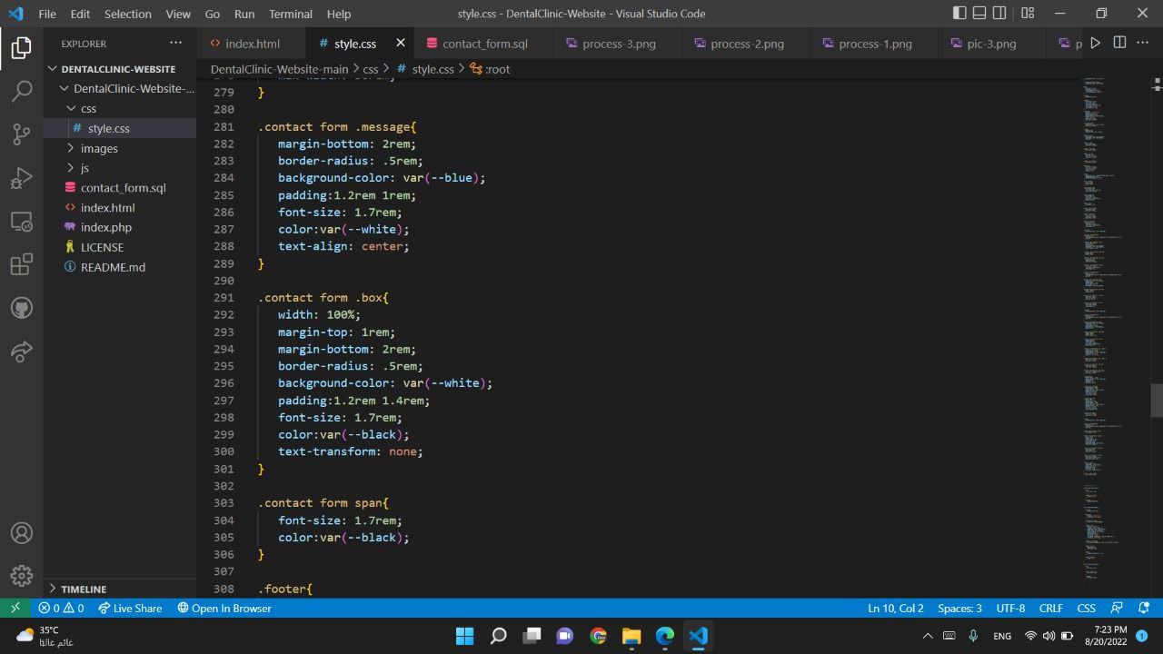

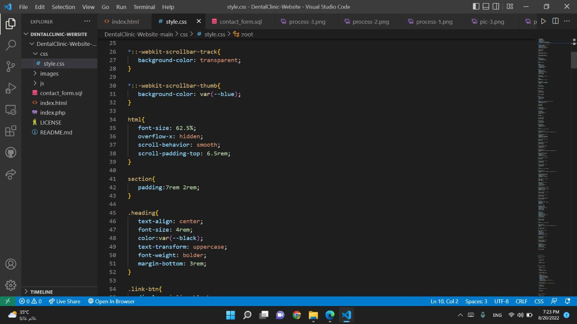

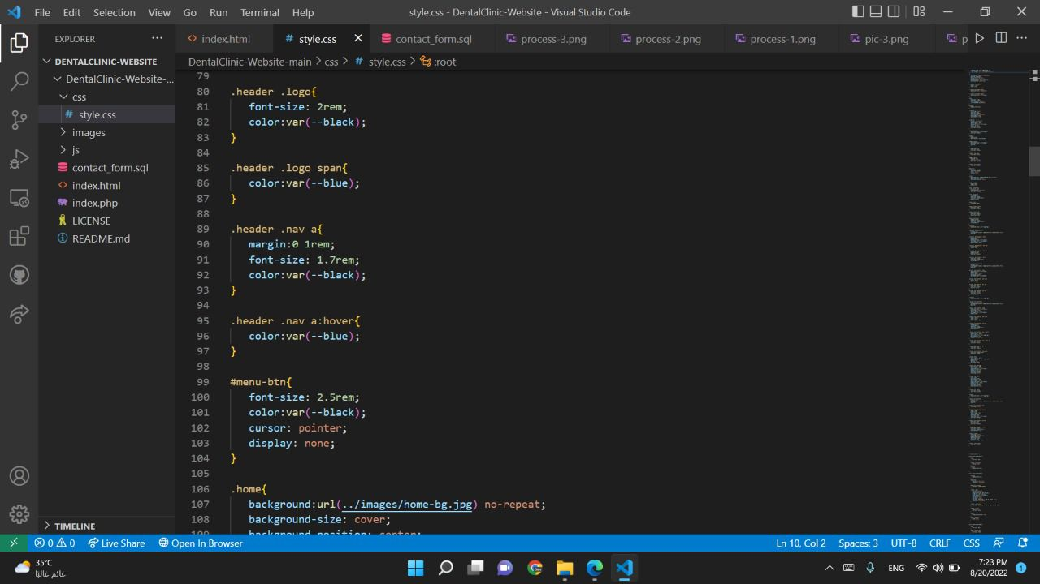

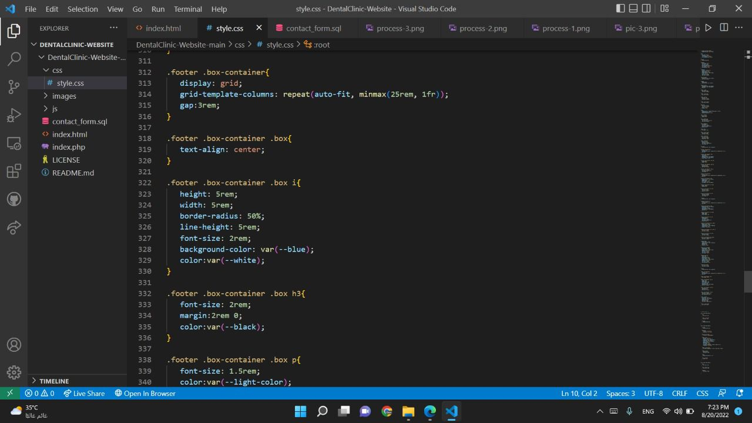

PHP code

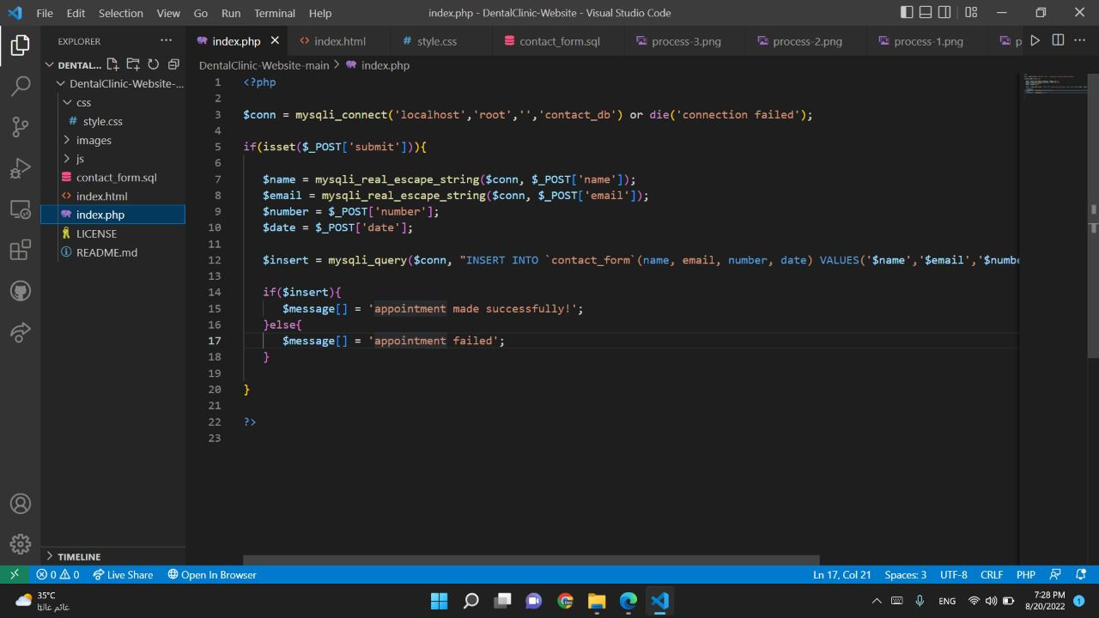

My sql

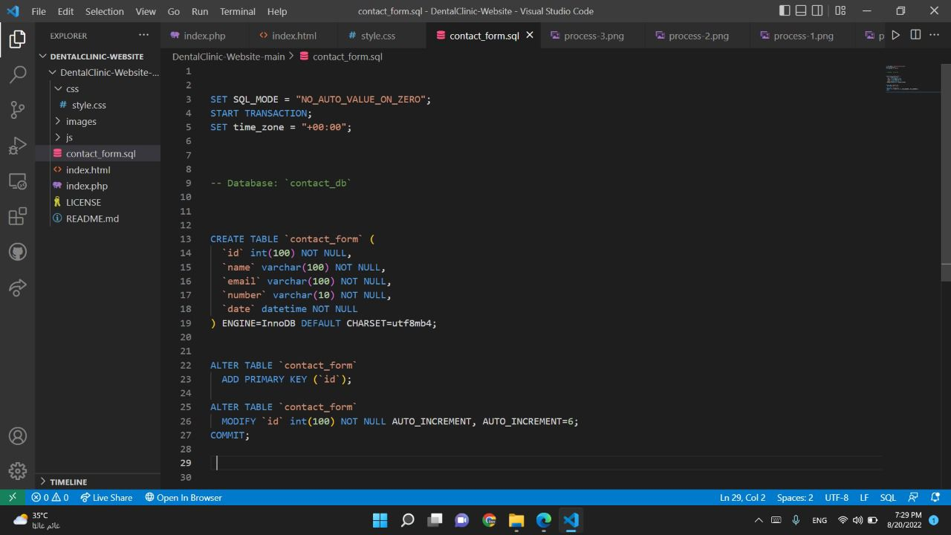

XAMPP

